Metropolitan Transportation Authority
New York City Transit

AC Train EMC Standards

Revision 2.3 Draft

February 18, 2003

MTA New York City Transit
130 Livingston Street

Brooklyn, NY 11201

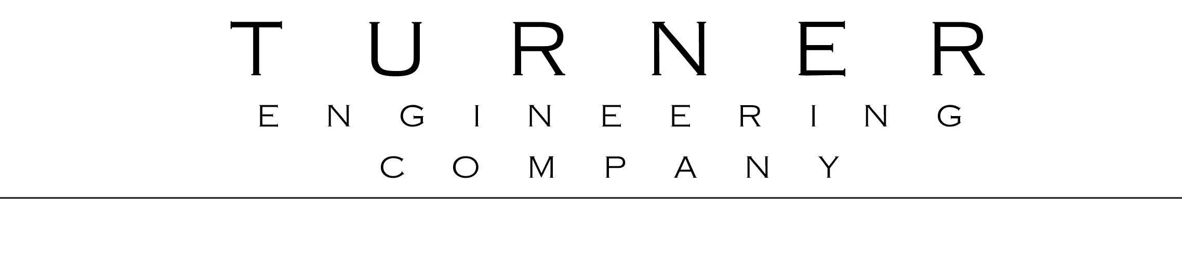Prepared by

Revision History

Date Revision Change

November 8, 1995 0.1 Initial full draft, from CETP and Project Plan documents

December 20, 1995 1.0 Initial release

January 31, 1996 1.1 Section 3.1: Clarify safety responsibility of carbuilder. Section 3.2.3: Clarify conducted emission limits and categories for evaluating emissions.

April 17, 2001 2.0 Change all references from NTT to AC Train. Incorporate improvements from R142/R142A AC Train procurement. Section 3.1: Expand modes to clarify spin-slide testing requirement. Section 3.2.1: Change rating from 20 kW to 10 kW. Section 3.2.2: Update CETP references. Clarify acceptance criteria. Section 3.3.1: Add reporting requirement. Section 3.3.3: Update Inductive Limits to match recent procurements. Section 3.4.1: Add reporting requirement. Section 3.4.2: Add limits at 50 ft and add graph. Section 4.1: Clarify safety analysis requirements. Section 4.2: Carbuilder is responsible to determine if EMI Detector is required. Section 5.3: Add frequency stability analysis requirement.

January 14, 2002 2.1 Section 3.4.2: Update Radiated Emission Limits table to match graph.

October 11, 2002 2.2 Section 3.4.2: Extend Radiated Emission Limits table and graph to cover range 10 kHz – 6 GHz.

February 18, 2003 2.3 draft Extend EMC Standard to include Radio Susceptibility Test and expanded Inductive Limits. Section 3.3.3: Add audio frequency inductive emission limit. Section 5.2: Add new subsections 5.2.2, DC Traction Current Susceptibility Provisions; and 5.2.3, Radio Susceptibility Provision. Add Section 6: Radio Susceptibility Test.

Table of Contents
Table of Contents ii
1 General Requirement 1
2 EMC Plan 1
3 Emissions Qualification Tests and Limits 2
3.1 Worst-case Tests 2
3.2 Conducted Emissions 2
3.2.1 Lab Conducted EMI Qualification Tests 2
3.2.2 Field Conducted EMI Qualification Test 3
3.2.3 Conducted Emission Limits 3
3.3 Inductive Emissions 4
3.3.1 Lab Inductive EMI Qualification Tests 4
3.3.2 Field Inductive EMI Qualification Test 5
3.3.3 Inductive Emission Limits 5
3.4 Radiated Emissions 6
3.4.1 Field Radiated EMI Qualification Test 6
3.4.2 Radiated Emission Limits 6
4 Safety Provisions 7
4.1 Safety Analysis 7
4.2 EMI Detector 8
4.3 Production Tests 8
4.4 Maintenance Tests or Procedures 9
5 EMC Design Report 9
5.1 Emissions 9
5.2 Susceptibility 10
5.2.1 Susceptibility Design Provisions 10
5.2.2 DC Traction Current Susceptibility Provisions 11
5.2.3 Radio Susceptibility Provisions 11
5.3 Frequency Stability 11

6 Radio Emissions Susceptibility Test and Evaluation Criteria 12
6.1 Radio Emissions Susceptibility Qualification Test 12
6.2 RSQT Evaluation Criteria 15

Metropolitan Transportation Authority New York City Transit
NYCT AC Train EMC Standards

General Requirement

The AC Train shall be electromagnetically compatible within itself, with other AC Trains provided by the Carbuilder, with all other trains in operation at NYCT, with the NYCT signal system and the Communications-Based Train Control System, with NYCT communications systems, with other NYCT electronic equipment, and with equipment owned by neighbors of the NYCT along its right of way. The AC Train shall not be capable of any operation that causes unsafe conditions in the signal system, as determined by the NYCT Engineer.

The Carbuilder shall perform a program which achieves and documents electromagnetic compatibility (EMC). The Carbuilder shall apply the EMC program requirements to all subsystems and suppliers. The Carbuilder shall ensure that all equipment, both individually and together, complies with the EMC requirements. The Carbuilder shall ensure that each AC Train configuration complies with the EMC requirements, in all possible operation modes. The Carbuilder shall work with NYCT and its suppliers to resolve any EMC problems discovered during execution of this Contract.

The Carbuilder shall conduct a program in which AC Train electromagnetic interference (EMI) emissions comply with EMI emission limits specified below.

EMC Plan

The Carbuilder shall develop an EMC Plan (EMCP) which describes the Carbuilder's organization to achieve EMC; activities and schedule; qualifications of personnel; and procedures and methods to achieve and document compliance with EMC requirements.

The EMCP shall address all requirements in this NYCT EMC Standard, and shall include scope, purpose, and requirements; project organization, schedule, and deliverables; EMC design report; EMC safety analysis; emission limits qualification test plans and testing; and plans for EMC-related production tests or maintenance tests.

The Carbuilder shall submit a draft EMCP for approval at the Preliminary Design Review.

The Carbuilder shall conduct and document activities described in the approved EMCP.

Emissions Qualification Tests and Limits

Worst-case Tests

The Carbuilder shall demonstrate through specified conducted, inductive, and radiated emissions qualification tests that the AC Train worst-case emissions are electromagnetically compatible with NYCT systems.

To determine the worst-case conducted, inductive, and radiated emissions, the Carbuilder shall perform the specified tests for normal, abnormal, and failed operating conditions; and in the full range of applicable operating modes, speeds, train lengths, and loading. The Carbuilder shall test modes including appropriate combinations of maximum and minimum acceleration; dynamic braking; regenerative braking; alternation between regenerative and dynamic braking when line receptivity changes, especially when line contactors open or close; spin-slide, especially in regenerative braking; HVAC and other auxiliaries at maximum and minimum power; in forward and reverse directions; with cutout propulsion and dynamic braking cut-out in one or more cars and trucks; and under failure conditions. Failure conditions shall include failures identified in the safety analysis of section 4.1, including relevant unannunciated failures as well as failures under which the AC Train can continue running at reduced performance, such as degradation or partial loss of a line filter capacitor bank.

For each test below, the Carbuilder shall develop a test procedure, and submit it for approval. The Carbuilder shall perform the tests to the satisfaction of NYCT. In each case, the Carbuilder shall document the test and submit a test report for approval. Lab tests shall be conducted as part of the subsystem qualification test. Field tests shall be conducted as part of the car qualification test.

Conducted Emissions

Lab Conducted EMI Qualification Tests

The Carbuilder shall perform Lab Conducted EMI Tests. The Carbuilder shall perform a test for each power unit with a rating greater than 10 kW, including the propulsion system, auxiliary electric converter, and other converters such as HVAC motor inverter.

The Carbuilder shall submit a Lab Test Procedure for each power unit for approval. The Lab Test Procedure shall include a quantitative analysis of the relationship between conducted currents measured on a unit under test in the lab and the resulting currents in NYCT track circuits during operation of the equipment on an AC Train at NYCT.

The Lab Test Procedure shall be compatible with Method RT/CE02A in UMTA-MA-06-0153-85-6, Conductive Interference in Rapid Transit Signaling Systems - Volume II: Suggested Test Procedures, May 1987, adapted for lab operation.

Section 3.2.3 below specifies conducted emission limits and refers to harmonic emission levels in NYCT track circuits which can be used as a design guideline. Appendix A of the NYCT Conducted EMI Test Procedure (NYCT CETP) provides a calculation method for relating train emissions to harmonic emission levels in NYCT track circuits.

The Carbuilder shall submit a Test Report which include a quantitative analysis of the relationship between the conducted currents measured in the lab and the resulting currents in NYCT track circuits during operation of the AC Train at NYCT.

Field Conducted EMI Qualification Test

The Carbuilder shall develop a Carbuilder Conducted EMI Test Procedure (Carbuilder CETP) compliant with the NYCT AC Train Conducted EMI Test Procedure (NYCT CETP).

The Carbuilder shall perform a Field Conducted EMI Test compliant with the Carbuilder CETP. The Carbuilder shall demonstrate that the AC Train's worst-case emissions on a NYCT test track do not disturb the worst-case NYCT track circuits, with the required margin. The Carbuilder shall submit a test report for approval which is compliant with the Carbuilder CETP and section 5 of the NYCT CETP.

Conducted Emission Limits

The conducted emission limits shall be as measured in and determined by a Conducted EMI Test of worst-case AC Train emissions in worst-case NYCT track circuits. Worst-case AC Train emissions shall be as determined per NYCT CETP section 2.2, and shall include operation of any or all AC Train equipment alone or in combination, and in normal, abnormal, and failed conditions. Worst-case track circuits shall be as described in section 6.2 of the NYCT CETP.

A test instrument setup supplied by the Carbuilder shall monitor and record the voltage across or current in the track relay, called the In-Circuit Relay. The test setup shall play back and amplify the monitored In-Circuit Relay signal by a specified gain, and drive the amplified signal into a separate track relay, called the Margin Test Relay. The amplified signal at the specified gain shall not disturb the normal operation of the Margin Test Relay. The specified gain is the margin against false operation of the relay.

NYCT has separated train emissions into three general categories: impulse emissions, repeating broadband emissions, and harmonic emissions, as defined in sections 2.2.4 and 2.2.5 of the NYCT CETP. The Carbuilder shall use these categories in evaluating the margin against false operation of the relay. In case of ambiguity or conflict, the NYCT Engineer shall solely determine which category and corresponding margin applies.

In summary, NYCT CETP section 2.2.4 defines an Impulse emission as an abrupt and brief change or set of changes in current which contains broadband energy and which, if of sufficient amplitude, can cause a track relay to wrongly change state, either by pickup or dropout, for a short time, such as for up to a half-second. Repeating Broadband emissions are comprised of several impulses occurring sequentially within a few seconds. Harmonic emissions are sustained emissions at a fixed or sweeping frequency which carry energy at a fundamental frequency.

The acceptance criteria for conducted emissions of an AC Train follow:

NYCT AC Train Conducted Emission Acceptance Criteria
Emission Category | Required Margin
Impulse | 6 dB or 2.0 x
Repeating Broadband | 12 dB or 4.0 x
Harmonic | 12 dB or 4.0 x

The Carbuilder shall arrange test runs so that usual test artifact events at block entry and turn-on of the regeneration load can be clearly distinguished from train events, such as mode transition and regeneration variation. NYCT CETP section 2.2.5 lists typical emission events. The NYCT Engineer shall solely determine whether an event is a train event or a test artifact event, in case of ambiguity or conflict.

The Carbuilder may use track circuit harmonic emission levels as a design guideline. NYCT CETP section 6.2 and Figure 6-5 identify harmonic emission levels which can cause wrong operation of NYCT worst-case track circuits. Appendix A of the NYCT CETP provides a calculation method for relating AC Train emissions to harmonic emission levels.

In using the harmonic emission levels as a guideline for designing components which affect EMI levels, the Carbuilder shall apply a minimum margin of at least 12 dB against false operation of a relay. In case of conflict between the Conducted EMI Test acceptance criteria and harmonic emission levels, the Conducted EMI Test acceptance criteria shall prevail.

Inductive Emissions

Lab Inductive EMI Qualification Tests

The Carbuilder shall perform Lab Inductive EMI Tests. The Carbuilder shall perform a test for each power unit with a rating greater than 10 kW, including the propulsion system, auxiliary electric converters, and other converter such as HVAC motor inverter.

The Carbuilder shall submit a Test Procedure for each power unit. The Lab Test Procedure shall be compatible with Method RT/IE04A in UMTA-MA-06-0153-85-8, Inductive Interference in Rapid Transit Signaling Systems - Volume II: Suggested Test Procedures, March 1987, adapted for lab operation.

The Carbuilder shall submit document the Lab Inductive EMI Tests results in a Test Report submitted to NYCT for approval. The report shall identify the source of each narrowband emission between 20 Hz and 20 kHz.

Field Inductive EMI Qualification Test

The Carbuilder shall perform a Field Inductive EMI Test.

The Field Test Procedure shall be compatible with Method RT/IE01A in UMTA-MA-06-0153-85-8, Inductive Interference in Rapid Transit Signaling Systems - Volume II: Suggested Test Procedures, March 1987.

The Carbuilder shall submit document the Field Inductive EMI Tests results in a Test Report submitted to NYCT for approval. The report shall identify the source of each narrowband emission between 20 Hz and 20 kHz.

Inductive Emission Limits

The train inductive emissions shall not exceed the following levels:

Inductive Emission Limits
Frequency (Hz) | Most Sensitive Relay Pickup Level (mV) | Emission Limit  (mV)
20 - 30 | 220 | 55
50 - 70 | 220 | 55
1 kHz to 20 kHz | [1] | 20

[1] Track signals in this frequency range will be used by NYCT for CBTC and other signal system components. Harmonic emissions in this range shall be stable, predictable, and fully documented.

At other frequencies, AC Train emissions shall be limited to reasonable values and shall be free of narrowband emissions.

Radiated Emissions

Field Radiated EMI Qualification Test

The Carbuilder shall perform a Field Radiated EMI Test.

The Field Test Procedure shall be compatible with UMTA-MA-06-0153-85-11, Radiated Interference in Rapid Transit Signaling Systems - Volume II: Suggested Test Procedures.

Additionally, the Carbuilder Field Test Procedure shall include measurements and documentation of radiated emissions as generated by the AC Train at a lateral distance of 72 in (1.83 m) from the centerline of the tangent track, at a height of 24 in (0.61 m) above the top of the running rails. These additional measurements shall be carried out for all test runs identified in the Field Test Procedure.

The Carbuilder shall submit document the Field Radiated EMI Tests results in a Test Report submitted to NYCT for approval.

The Carbuilder shall be responsible to cooperate in the satisfactory resolution of any complaints regarding radio, television, and telephone interference received by NYCT and attributed to the AC Trains.

Radiated Emission Limits

The Radiated emissions shall not exceed the following emission limits, plotted as straight lines on a graph of dB microvolts per meter per megahertz (dBµV/m/MHz) versus log frequency, when measured at the indicated distance:

Radiated Emission Limits
Frequency Range (Hz) | Limit at 50 ft  (dBµV/m/MHz) | Limit at 100 ft  (dBµV/m/MHz)
10 kHz | 126 | 108
150 kHz | 126 | 108
1.6 MHz | 115 | 97
3.2 MHz | 100 | 94
200 MHz | 81 | 75
1.0 GHz | 96 | 90
6.0 GHz | 96 | 90

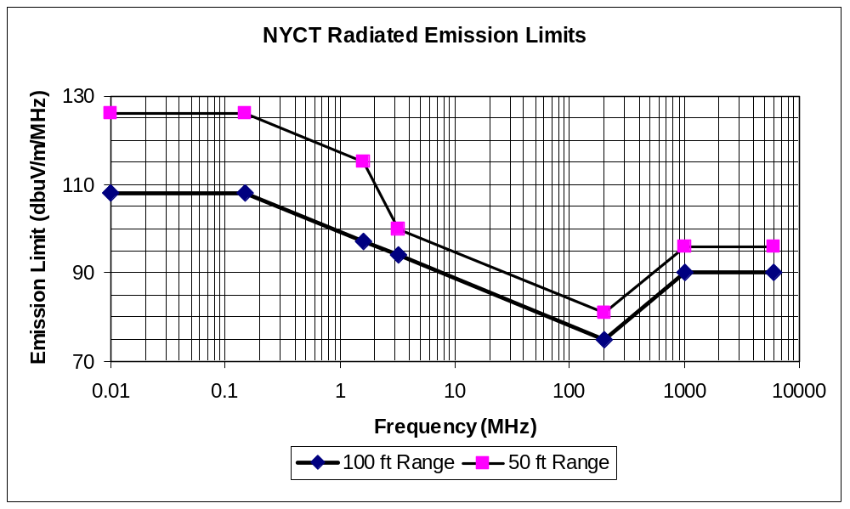

Safety Provisions

The Carbuilder shall perform and submit for approval a safety analysis which demonstrates that NYCT is protected against hazards due to EMI.

Safety Analysis

The Carbuilder shall submit for approval a safety analysis which documents that the AC Train's EMI emissions are safe under normal conditions, and that the AC Train equipment provides adequate detection, annunciation, and response to failures which could cause EMI to increase above tested levels. The safety analysis shall include a Preliminary Hazard Analysis (PHA); a Fault Tree; and Failure Modes, Effects, and Criticality Analyses (FMECA) of appropriate equipment.

The safety analysis shall document the protective actions which prevent a hazard occurrence. The safety analysis shall demonstrate that the equipment and its actions are adequate to prevent an EMI hazard.

The safety analysis shall distinguish between EMI-affecting failures which are automatically protected, those which are annunciated for operator or maintainer action, and those which are unannunciated failures. Train worst-case tests specified above shall include all annunciated and unannunciated EMI-affecting failures.

The safety analysis FMECA shall consider all relevant failures of AC Train equipment, and shall document failures, failure effects, probabilities, and impacts on car equipment and on the AC Train performance in the NYCT transit system. The FMECA shall consider, at least, line filter inductors, capacitors, and wiring; inverter components and particularly frequency determining elements and IGBT switching frequencies, times, delays, and offsets; traction motors; and the EMI Detector, if one is provided. The FMECA shall consider the equipment operating under unusual operating conditions. The FMECA shall consider failures of wayside equipment affecting and involving trains, such as a substation rectifier diode failure.

Failure probabilities used in the Fault Tree Analysis shall be traceable to the FMECA or other detailed reliability analysis.

EMI Detector

As part of the protection against failures causing EMI hazards, the Carbuilder may provide an EMI Detector to detect, annunciate, and protect against train and substation failures which can affect normal signal system operation.

If the Carbuilder provides an EMI Detector, the EMI Detector shall be incorporated into the overall EMC control plan. The Carbuilder shall submit for approval a Final Design Review document describing the EMI Detector design; detection frequencies and processing; emission thresholds, bandwidths, corresponding protective actions, and tolerances; impacts on train and system operation of EMI Detector action; Carbuilder recommended procedures for NYCT staff to restore service; car-level and driver's console annunciations; and EMI Detector self-test, failure modes, and failure annunciation. The Carbuilder shall provide an EMI Detector FMECA and an which documents the interactions and responses of all EMI Detectors on a train to failures on one or more cars; to failure on the wayside, such as of a substation diode; and to failure of the EMI Detector. The EMI Detector shall include a continuous or regular self-test provision to ensure its integrity.

If the Carbuilder does not provide an EMI Detector, the safety analysis of section 4.1 above shall document that NYCT is adequately protected against EMI hazards without the EMI Detector.

Production Tests

The Carbuilder shall identify EMC-related production tests, if any, which will be performed on each railcar to assure protection against EMI hazards.

Maintenance Tests or Procedures

The Carbuilder shall identify EMC-related maintenance tests or procedures, if any, which will be performed on each railcar to assure protection against EMI hazards.

EMC Design Report

The Carbuilder shall provide an EMC Design Report documenting the EMC characteristics of the electrical and electronic portions of the AC Train. The EMC Design Report shall consist of an Emissions Report section and a Susceptibility Report section.

Emissions

The Carbuilder shall control on-board equipment emissions to achieve EMC. The Carbuilder shall submit a completed Emissions Report for approval at the Final Design Review. The Emissions Report shall document the design provisions to achieve the specified limits:

- EMC emission control methods, including equipment layout, circuit routing, frequency coordination, filters, interconnections, grounding, and shielding. The Carbuilder method shall conform to IEEE Std 1100-1992, Recommended Practice for Powering and Grounding Sensitive Electronic Equipment, unless otherwise approved.

- Description of each unit with a peak power rating of greater than 10 kW, including the emission characteristics versus operating mode and loading, as well as line filter, output filter, line input impedance, and circuit and operating mode considerations.

- EMI Detector, if one is provided.

- For the car as a whole, the simulated or calculated combined emissions of the car.

- For each AC Train configuration, the simulated or calculated combined emissions in the NYCT worst-case track circuits.

Susceptibility

Susceptibility Design Provisions

The Carbuilder shall control on-board equipment susceptibility to achieve EMC. The Carbuilder shall submit a completed Susceptibility Report for approval at the Final Design Review. The Susceptibility Report shall document the design provisions to achieve suitable susceptibility control of AC Train equipment:

- EMC susceptibility control methods, including equipment layout, equipment enclosure design, circuit routing, frequency coordination, filters, interconnections, grounding, and shielding.

- The railcar high voltage and low voltage circuits, arrangement, separation, and routing.

- The high voltage and low voltage grounding arrangement, and provisions for worst-case ground voltages within the railcar.

- The normal and fault paths for ground currents.

- For each type of electrical interface between subsystems or enclosures, such as battery, digital logic, analog, and serial data communication:

- The driving circuit, including impedance and maximum and minimum output voltage and current levels.

- The receiver circuit, including maximum and minimum voltage or current thresholds, margin against error, destructive threshold.

- All aspects of the connection requirement, such as single wire, double wire, twisted pair, shield, and shield grounding.

- Any special circuit or connection provisions needed to ensure EMC.

The Carbuilder shall ensure that the railcar equipment is adequately protected against radio frequency emissions from nearby mobile and handheld radios or cellular telephones that the equipment can encounter during normal passenger use or NYCT operations.

The Susceptibility Report shall describe the equipment protections as well as any restrictions on equipment operation or maintenance necessary to ensure susceptibility control, such as leaving covers on equipment enclosures.

The Carbuilder shall demonstrate the adequate susceptibility control of any non-service proven interface.

DC Traction Current Susceptibility Provisions

The Carbuilder is responsible to design and provision the AC Train as necessary for reliable operation in the NYCT environment. The NYCT environment includes high magnetic and electric fields from high currents and transients in the traction power system and third rail, as well as from NYCT and neighbor radio systems.

Radio Susceptibility Provisions

The Carbuilder shall ensure that the AC Train equipment is adequately protected against radio frequency emissions from nearby mobile and handheld radios or cellular telephones that the equipment can encounter during NYCT operations.

The Susceptibility Report shall describe the equipment protections, as well as any restrictions on equipment operation or maintenance necessary to ensure susceptibility control, such as leaving covers on equipment enclosures.

Frequency Stability

If any repeating narrowband emissions are found during testing with amplitudes above the applicable limit levels but at frequencies near but outside the bandwidths of the NYCT worst-case track circuits, these emissions shall be examined in detail by the Carbuilder to ensure EMC. In particular, the stability of the emission frequencies must be demonstrated, under any condition, to remain outside the critical bandwidths of the NYCT worst-case track circuits. The Carbuilder shall submit an analysis to the satisfaction of NYCT.

Radio Emissions Susceptibility Test and Evaluation Criteria

The AC Train and its equipment shall be immune to emissions from portable radio transmitters (radios) commonly in use at and around NYCT.

The Carbuilder shall perform a Radio Susceptibility Qualification Test on the completed AC Train to demonstrate the immunity of the AC Train and its equipment against radio emissions.

Radio Emissions Susceptibility Qualification Test

The Radio Emissions Susceptibility Qualification Test (RSQT) shall subject all AC Train electrical and electronic equipment to radiated emissions from an approved list of radios in use at and around NYCT. The RSQT shall monitor the integrity of the equipment functions during the test, with the AC Train in all applicable operating modes specified in Section 3.1. Additionally, the RSQT shall monitor the integrity of equipment functions in maintenance mode, such as when normally closed equipment enclosures are opened for inspection. The AC Train passes the RSQT if its responses conform with the pass/fail criteria below. The Carbuilder shall document the test results in a RSQT Test Report submitted to NYCT for approval.

The Carbuilder shall submit a RSQT test procedure to NYCT for approval. The RSQT test procedure shall specify:

- The detailed list of radios to be used in the RSQT.

- The AC Train operating modes to be tested, per Section 3.1 above.

- The AC Train equipment items to be tested and their locations on the AC Train. The AC Train equipment items shall include all electrical and electronic equipment items on the AC Train.

- Enclosures containing electrical or electronic items that can be opened for maintenance when portions of the AC Train equipment are operating. The RSQT test shall include tests of such enclosures while opened, unless warning labels printed on the equipment enclosure specifically caution against this.

- For each AC Train equipment item, the indications the Carbuilder will monitor to assess the integrity of the equipment functions during testing.

The radios to be used in the RSQT shall consist of the radio transmitters listed in the following Table 6-1a and Table 6-1b, plus additional radios as designated by NYCT or recommended by the Carbuilder. NYCT will make NYCT radios available to the Carbuilder for the test. The radios in Table 6-1a are portable radios, and shall be used to test equipment inside and outside the AC Train. The transmitters in Table 6-1b are not portable, and shall be used to test equipment only on the outside of the AC Train.

The RSQT test report shall list each radio manufacturer, model number, and serial number; frequency or channel used; nominal transmit power rating; and measured field strength at a distance of 1 ft, in volts/meter (v/m). The RSQT shall measure the radio field strength with a suitable instrument, such as a Spectrum Analyzer with calibrated antenna, or a suitable Field Strength Meter such as the IFI EFS-5 with #0301-S probe or the Credence Technologies CTM041.

Each internal or external AC Train equipment item shall be tested by placing the Table 6-1a portable radio into the transmit mode and moving the radio past the equipment at a rate of 1 foot per second (fps) or less along the path shown in Figure 6-1, or for a minimum of 10 s for small equipment.

Table 6-1a

Portable Radio Transmitters for RSQT
Radio | Frequency | Modulation / Typical Power
NYCT Operations | 136 – 174 MHz | FM / 6 W
NYCT Operations | 403 – 512 MHz | FM / 4 W
NYCT Police | 806 – 869 MHz | TDMA - FDMA - FM / 3 W
Cellular | 824 – 849 MHz | CDMA or TDMA / 0.6 W
Cellular PCS  (Personal Communication System) | 1,851 – 1,909 MHz | PCS / 0.3 W

While moving along the path, the radio shall be positioned 1 ft from the equipment surface. However, if the placement and function of the equipment makes it possible that a radio will normally be operated closer than 1 ft from the surface, the radio shall be positioned closer to the equipment surface during the test. During the test, the radio shall be rotated so the radio transmit antenna alternates between the horizontal and vertical polarity at about a 1 Hz rate.

Each external AC Train equipment item shall be tested by placing the Table 6-1b non-portable transmitter into the transmit mode, positioning the transmitter and AC Train so the transmitter is 3 ft from the AC Train equipment item, and operating the transmitter for a minimum of 10 s. If the mounting of the non-portable transmitter prevents placing it 3 ft from the AC Train equipment, position the transmitter and AC Train as close together as possible.

Table 6-1b

Non-Portable Transmitters for RSQT
Transmitter | Frequency | Modulation / Typical Power
NYCT CBTC Radio | 2,400 – 2,500 MHz | Spread Spectrum / 1 W
1000 W Microwave Oven [1] | 2,400 – 2,500 MHz | Broadband impulse / 14 v/m
[1] Use Microwave Oven as radiator. Place a piece of 2 mil plastic in door seal to achieve leakage similar to worn door seal, leading to a level of approximately 14 v/m at a distance of 3 ft.

The Carbuilder may propose modifications to the radio path and placement as necessary to fit physical constraints of the AC Train equipment layout.

Figure 6-1
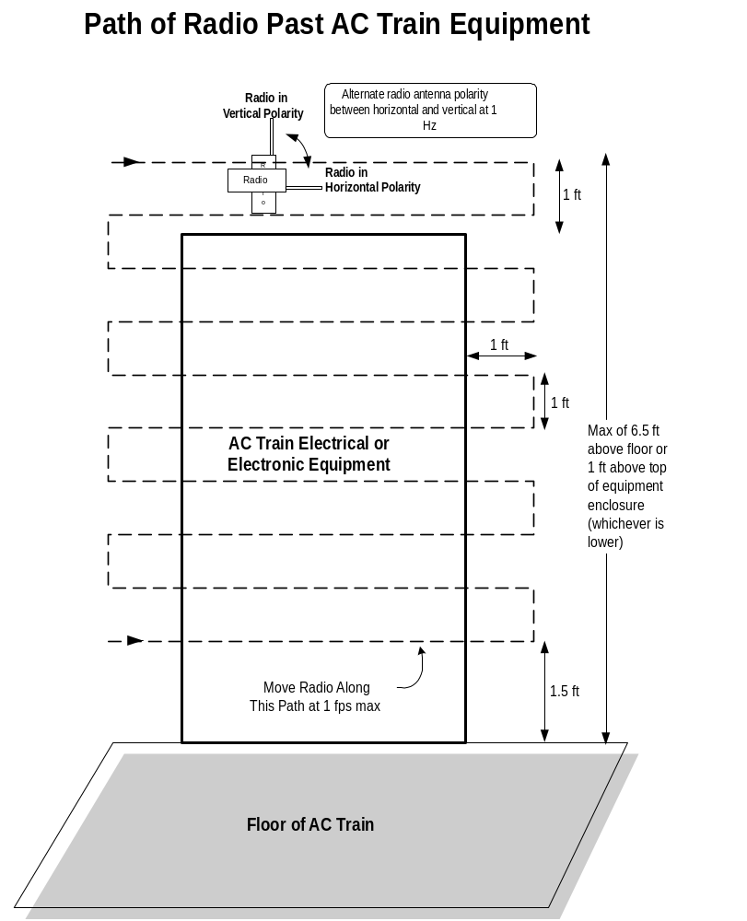

RSQT Evaluation Criteria

The RSQT shall use the evaluation criteria in Table 6-2:

Table 6-2

RSQT Evaluation Criteria
Category | Effect on Function or Performance of AC Train Equipment
A | - No effect on function or performance of AC Train equipment.
B | - Minor effect during exposure to radiated emission. Effect ends when exposure to radiated emission ends.
C | - Major effect, such as AC Train unsafe or unacceptable action or response.  - Major or minor effect requires operator action to reset or restore after exposure to radiated emission ends.
D | - Effect requires maintainer action to repair or restore after exposure to radiated emission ends.

The RSQT shall use the pass/fail criteria in Table 6-3:

Table 6-3

RSQT Pass/Fail Criteria
Category | AC Train in Normal or Abnormal Operating Mode | AC Train in Maintenance Mode  (e.g., enclosure cover open)
A | Acceptable | Acceptable
B | May be acceptable with NYCT review and approval | Acceptable
C | Unacceptable | May be acceptable with NYCT review and approval
D | Unacceptable | Unacceptable

For each test, the RSQT test report shall document the equipment under test, the radios used, and the category of the resulting response for each radio. For any item which is ‘May be acceptable with NYCT review and approval’ or ‘Unacceptable’, the RSQT test report shall provide full details of the equipment response.

